**GDSC PIEAS Web Development Bootcamp**

*Assignment No: 1*

*Name: Abdul Rehman*

*Email:* [*bc220424444are@vu.edu.pk*](mailto:bc220424444are@vu.edu.pk)

**Solution Code:**

<!DOCTYPE html>

<html lang="en">

<head>

<meta charset="UTF-8">

<meta name="viewport" content="width=device-width, initial-scale=1.0">

<title>Abdul Rehman Portfolio Website</title>

</head>

<body>

<h1>Task 1:</h1>

<button>Abdul Rehman</button>

<button>Mango</button>

<hr>

<h1>Task 2:</h1>

<a href="https://www.youtube.com/channel/UC0U-CjmrinC6I3Gb1dOk0WA">My YouTube Channel</a>

<hr>

<h1>Task 3:</h1>

<h2>Abdul Rehman</h2>

<p>My Skills are:</p>

<li>Programming</li>

<li>Web Development</li>

<li>Video Editing</li>

<hr>

</body>

</html>

**Coding Screenshot:**

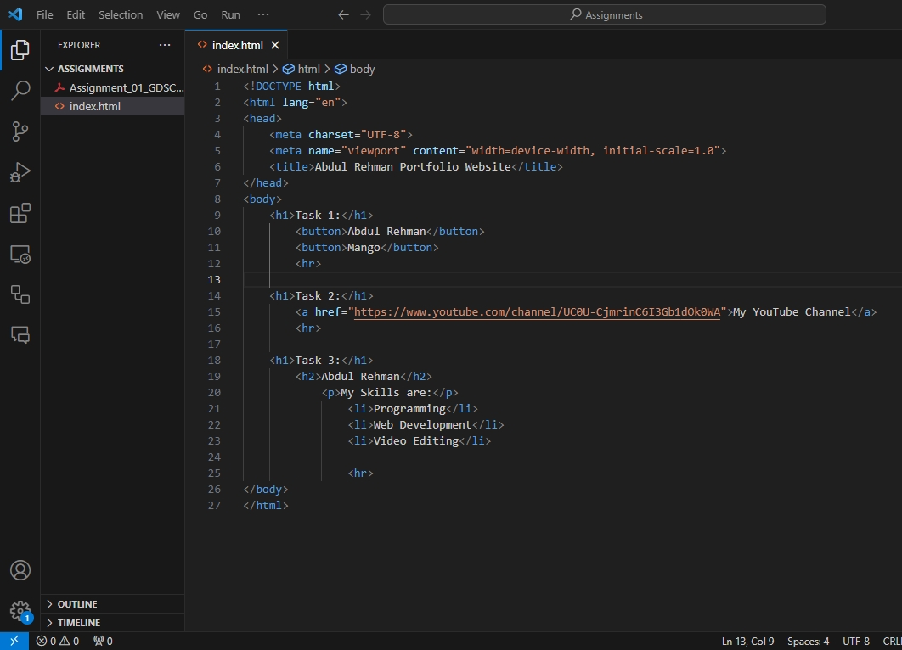

**Output Screenshot:**

